Why - Change components without affecting other ones, with own dependencies with own libraries, all on same OS but with separate containers and environments

Shows how to set up and install docker

Platform for building, running, and shipping apps consistently
So if it works on dev machine, can work and run the same way on other machines
- What would cause it not to run?
  - Files missing
  - Software version mismatch (ex: your machine runs node 9, but other computer has node 10)
  - With docker, we can easily package app with everything it needs, and run it anywhere
  - So if it works on dev machine, will def run on test and prod machine

Just tell docker to bring up your app, it’ll automatically do it and run it in an isolated environment called a container
- So one container can be running node 14 with app 1
- And another container can be running node 9 with app2
- Since they are isolated, we can do this! Can run them side by side on same machine without disturbing the other
- And let’s say we wanted to get rid of one of the containers – we can remove it and it will not affect the others
- No worries taking away one and messing up the others with dependencies

Container vs VM
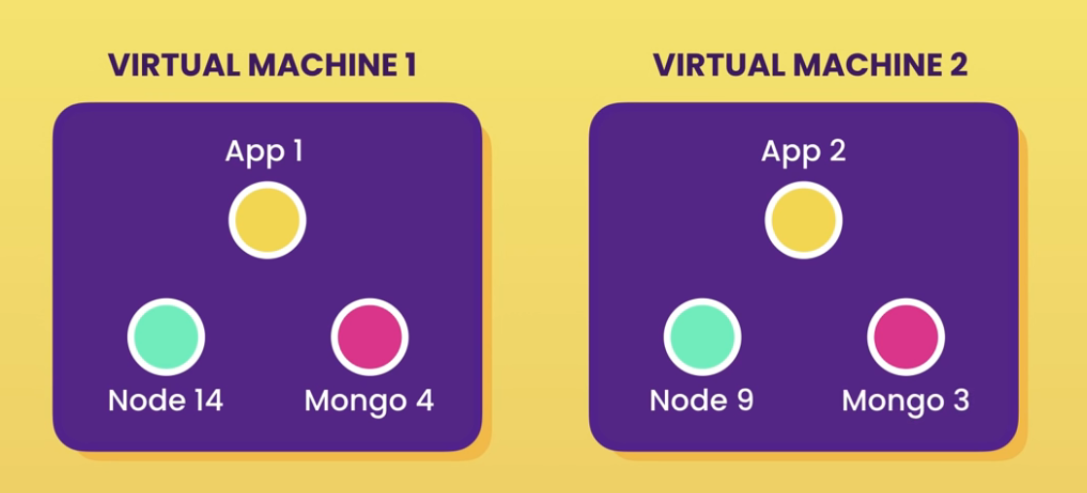
- Problems: each VM needs a full copy of an OS, license, etc
- Resource intensive because each VM takes a slice of resources like CPU, etc

Containers give us same isolation, but…
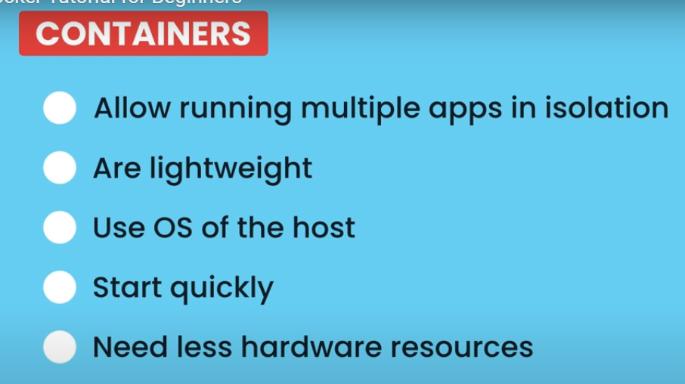

All containers on host share OS on a host
- They share kernel of the host

https://www.google.com/search?q=docker+for+beginners&rlz=1C1ONGR_enUS1075US1075&oq=docker+for+beg&gs_lcrp=EgZjaHJvbWUqBwgAEAAYgAQyBwgAEAAYgAQyBggBEEUYOTIHCAIQABiABDIHCAMQABiABDIHCAQQABiABDIHCAUQABiABDIGCAYQRRg8MgYIBxBFGDzSAQgxODY0ajBqN6gCALACAA&sourceid=chrome&ie=UTF-8#fpstate=ive&vld=cid:795753f3,vid:pTFZFxd4hOI,st:0 how to download docker @ 13:42

Development Workflow
- Take an app, dockerize it
  - And the way we do this, we include a docker file
    - a plaintext file that includes instructions that docker uses to package app into an image, which contains everything our app needs to run
    - 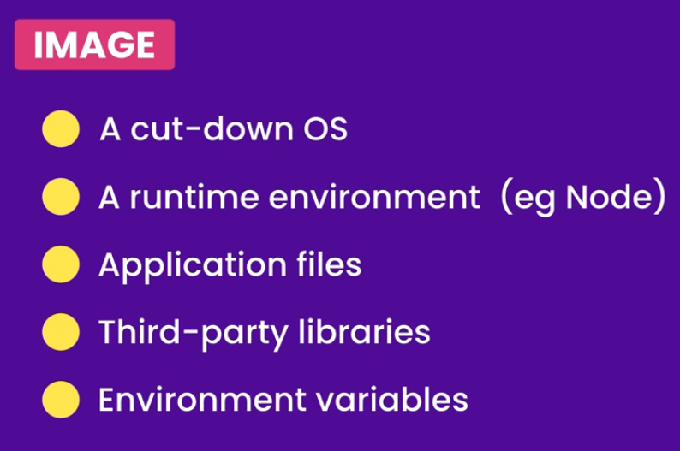

Container is just a process that uses image to run everything accordingly
- Has its own file system provided by image
- Gets put in container and this is how it runs on machine locally

Once we have image, can push it to registry like dockerhub
- Which is like github to git
- Has the same image on our machine so we can then pull it from anywhere

18:08 – docker in action run it on own computer
Start in vs code – file we will dockerize

NODE an execution environment for javascript code

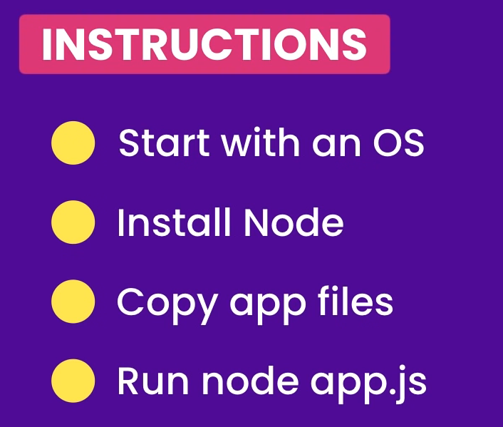
- For simple program
- But with docker, we can write these instructions inside docker file and docker will handle all of this

So we are editing in vs code. We have js file and now a docker file
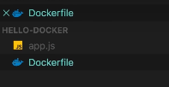

In Dockerfile
- Typically start from base image we take files and add files to it
  - Like inheritance
- We are going to start from node image
  - All image names can be found on dockerhub
- Tag which distribution to use
- So for us, we are going to use alpine
  - 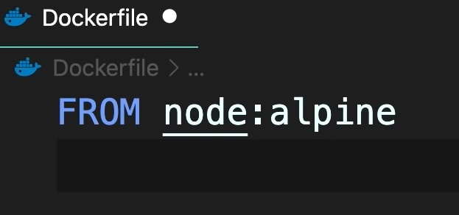
  - Tag is denoted with :
- Then copy files
  - We are going to copy all of the files in the current directory into the new directory called /app so it can be packaged
  - 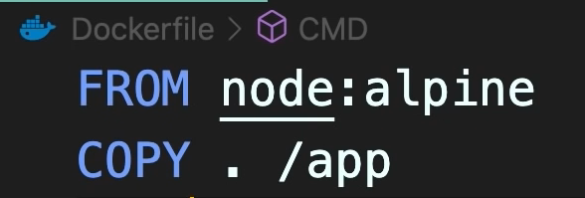
- Lastly, use cmd to actually run and need to specify directory we are running it from
  - 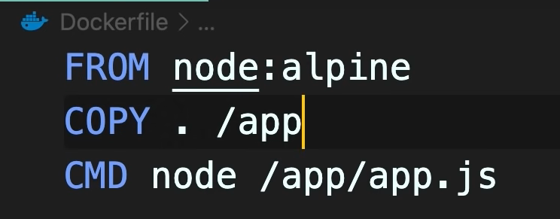
  - Alternatively, we could set working directory:
  - 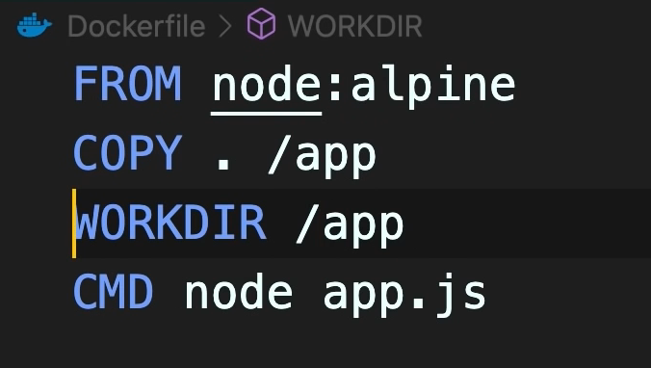

We have docker file. Now we must go to the terminal and tell docker to package up our application docker build!
- So go to git in the hello-docker directory we made
  - Docker build _____
    - We need to give image a tag -t
    - So docker build -t hello-docker .
      - Hello-docker is the name we are giving the image
      - And then we need to say where we can find docker file
      - . references current directory

In terminal, to see images docker image ls
- And it will show you name created and tag size
  - For us it shows tag latest
  - Each image has unique Identifier

So we have build image. Now we can run this image on any computer running docker
- Docker run hello-docker
  - Where hello-docker is the image name, we can see it in docker image ls
  - This is now running in a container

Output is to see our Hello Docker! Js output in the terminal
- We can put this on docker hub so anyone can pull it
- And run it on any computer

What if we want to run existing image? EX: codewithmosh/hello-docker
- Docker pull codewithmosh/hello-docker
- Docker image ls (to get image name)
- Docker run codewithmosh/hello-docker

- Do not need to build because it already has been packaged, we pulled it. We would build if it hasn’t been packaged yet

Ubuntu ---> a linux distribution
- Alpine Is one too



Docker ps all running containers
Docker ls all images

Basic commands
- Run: run a container from an image
  - If image not present on host, will go out to docker hub and pull image down
  - Run container from image, must specify an image name from docker hub website > explore
  - We are going to use example: centos
    - Docker run centos
      - First it will try to find image locally, and if not, will pull it down and give you the latest image of centos
      - So it ran, but it didn’t actually do anything
      - To keep container alive, need to run
        - So we will run again and ask for bash
        - Docker run -it centos bash
          - It will look at command later
          - So now docker runs centos and then runs bash command, and it logs us into container
- Ps: lists all running containers
  - Gives info like container id, current status, name of container
  - Ps – a all running containers
  - Shows nothing running right now because we exited
  - So if we run again:
    - 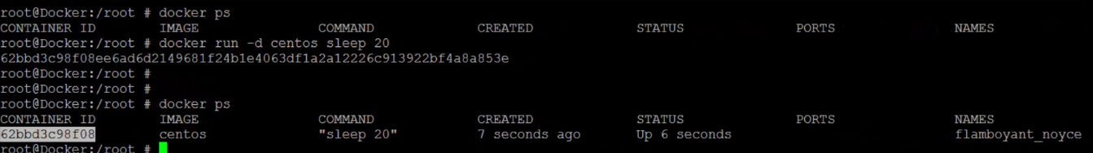
    - Ps -a all containers that have run and completed
- Stop: stop a container from running
  - Provide name of container or give container ID
  - Will force kill container
  - And if you run ps again, you will see this container is no longer running
- Rm: remove container
  - Provide container id or name get both from ps
  - Do this to reclaim disc space
- Images: a list of available images
  - 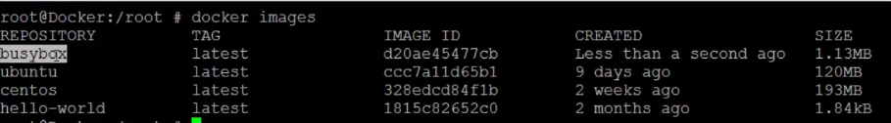
- Rmi: remove image. But must make sure no containers are running off of that image
  - 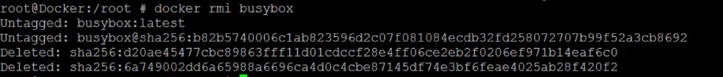
- Pull: download an image
  - 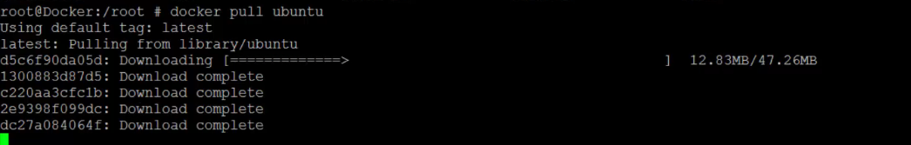
  - Stores it locally on the computer
- Exec: execute command on a running container
  - 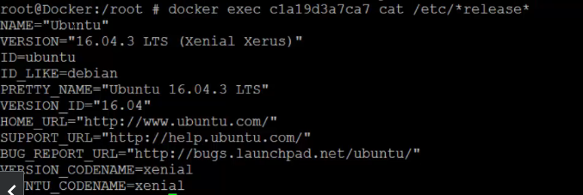
  - Gives an output
- Run: attach and detach

Docker is used for building and running multiple transferable environments, whereas Jenkins is an automated software testing tool for your app. On the other hand, Kubernetes is a system for automating deployment, scaling, and management.

Docker run
- Can handle port mapping
- Can handle volume mapping
- Inspect command provide container name and ID in json format so you can understand what’s going on
  - Details on container
- Can run different versions of a tag tags are respective dockerfile links

How to create an image?
- Create a docker file
- Write down instructions on how to set up everything
- Dockerize it
  - 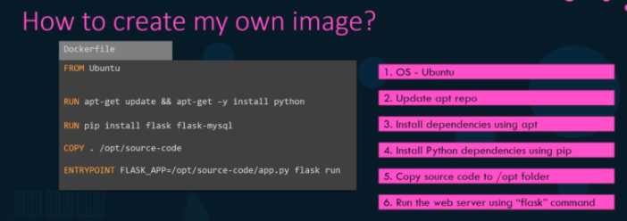
- Build image 
- Will create image locally on your system
- If you wanted it on dockerhub, run push command:
  - 

Docker file is a text file that has instructions and argument format so docker can run it
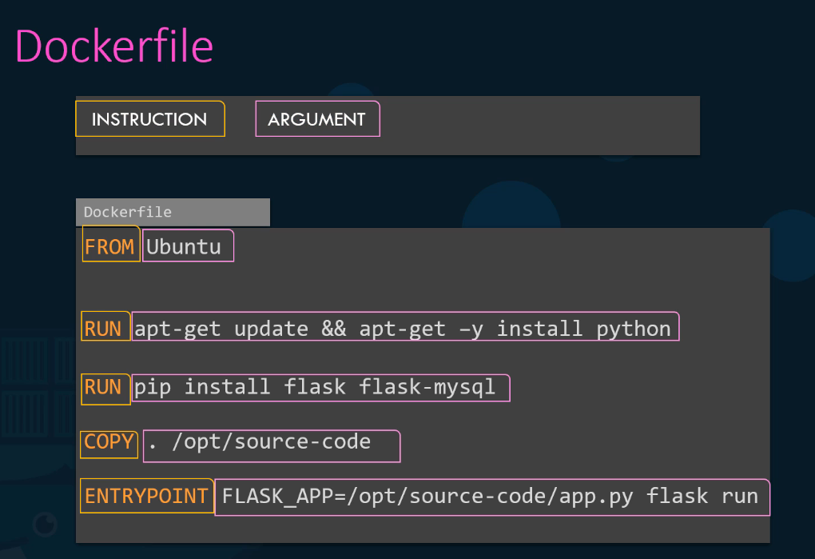

In udemy course creating new docker image

By default, docker container does not do standard input
- If you want it to take this into account, -i parameter
  - I stands for interactive mode
- -it input + standard terminal
- This puts it into interactive mode

